CAT 2 SIMULATION AND MODELING

Question 1: Upload the dataset and take “species” to be the dependent variable and others to be independent.
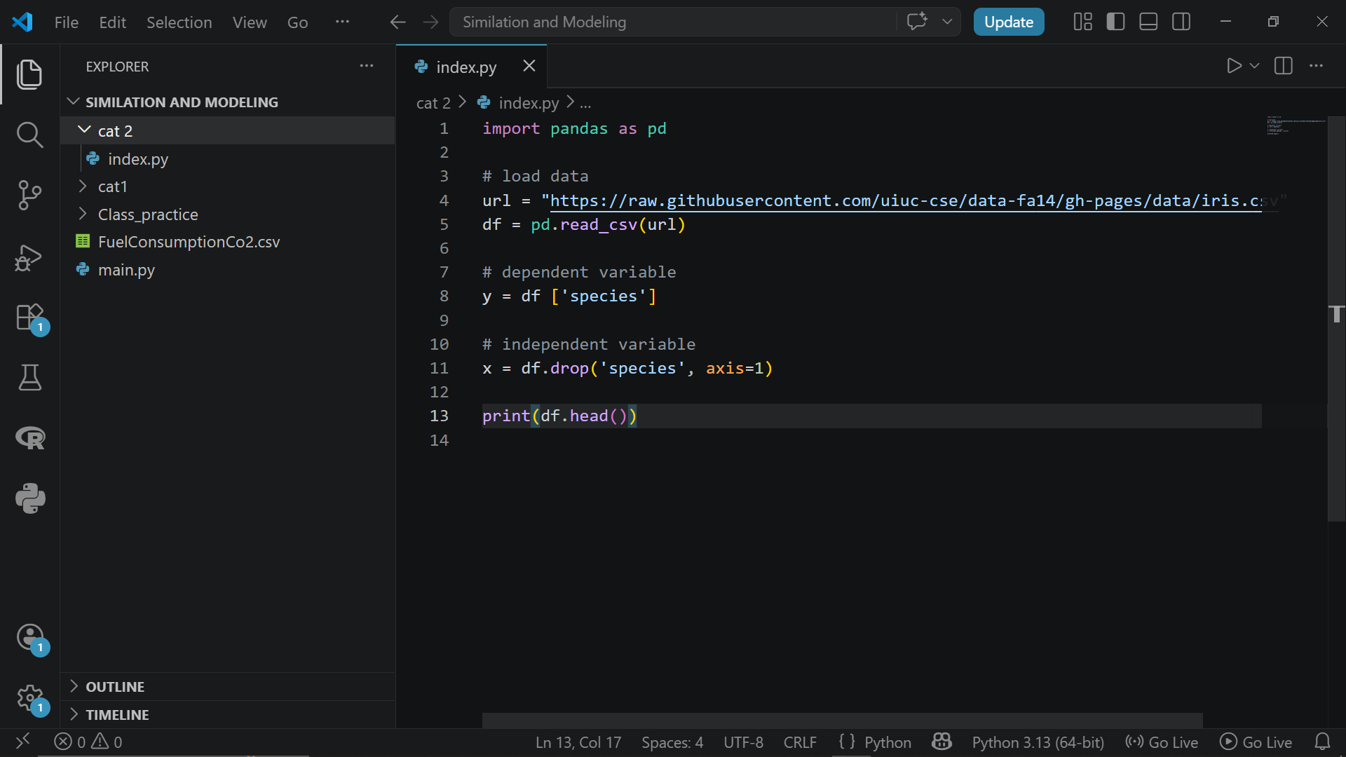

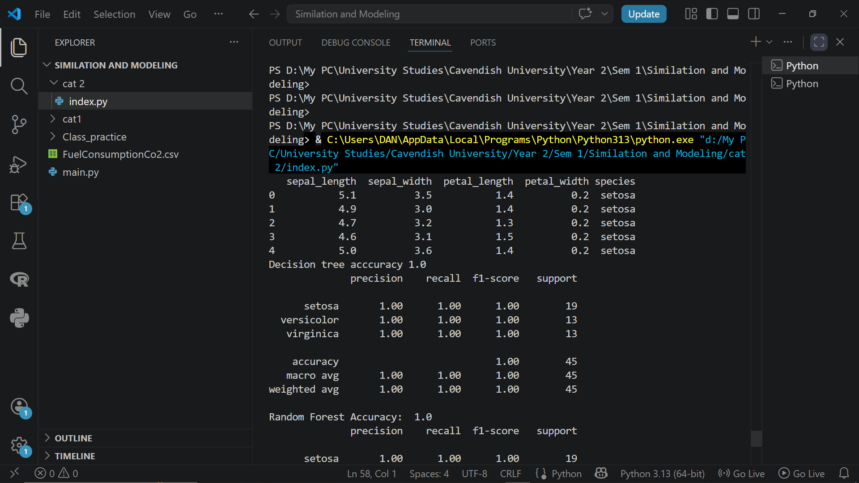

Question 2: Use decision trees, random forest and support vector machine classifiers to predict different species by determining the performance metrics such as precision, recall, F1-scores and accuracies for each of the classifiers

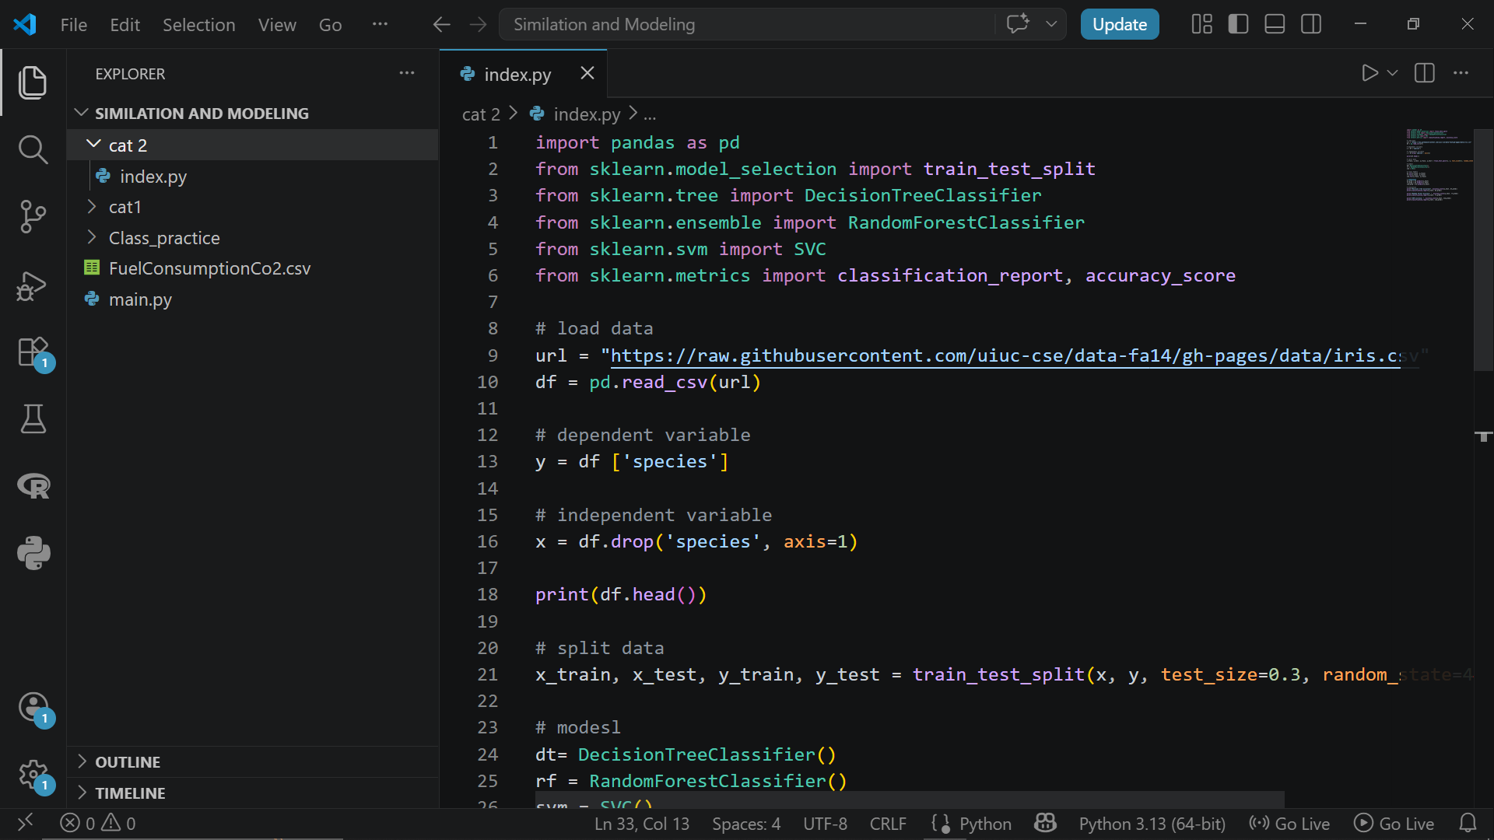
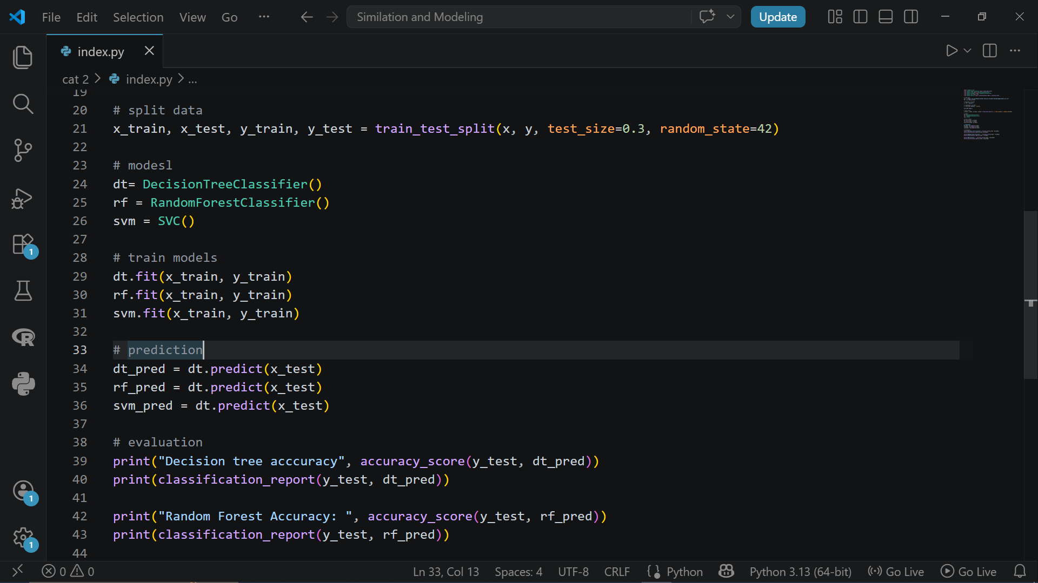
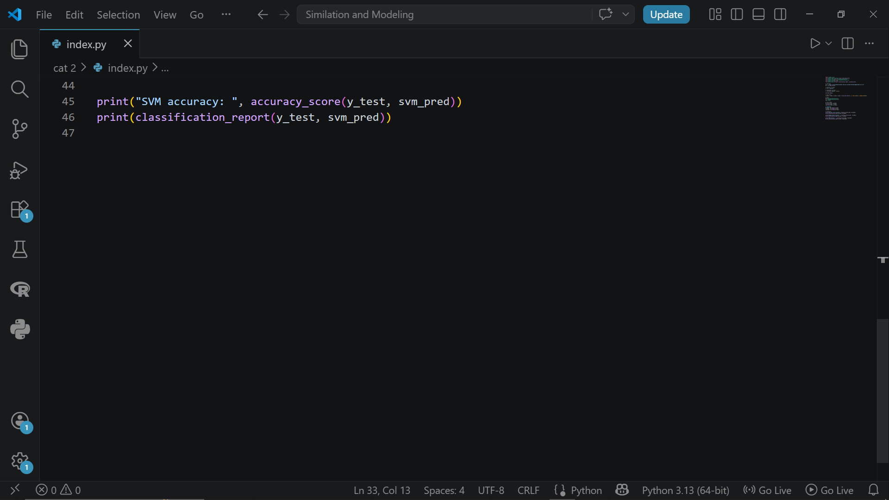
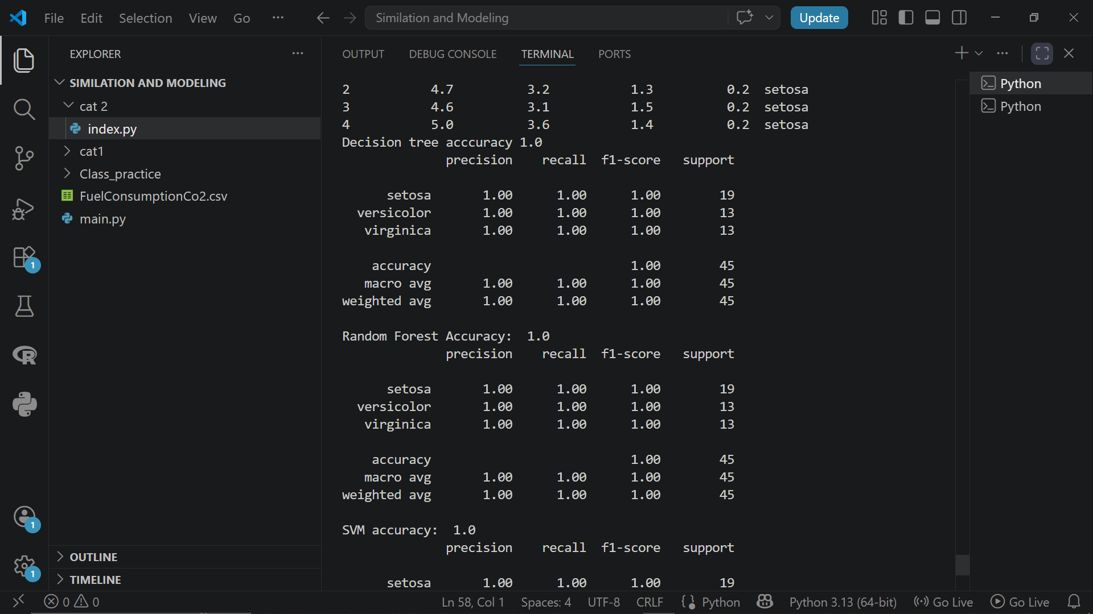
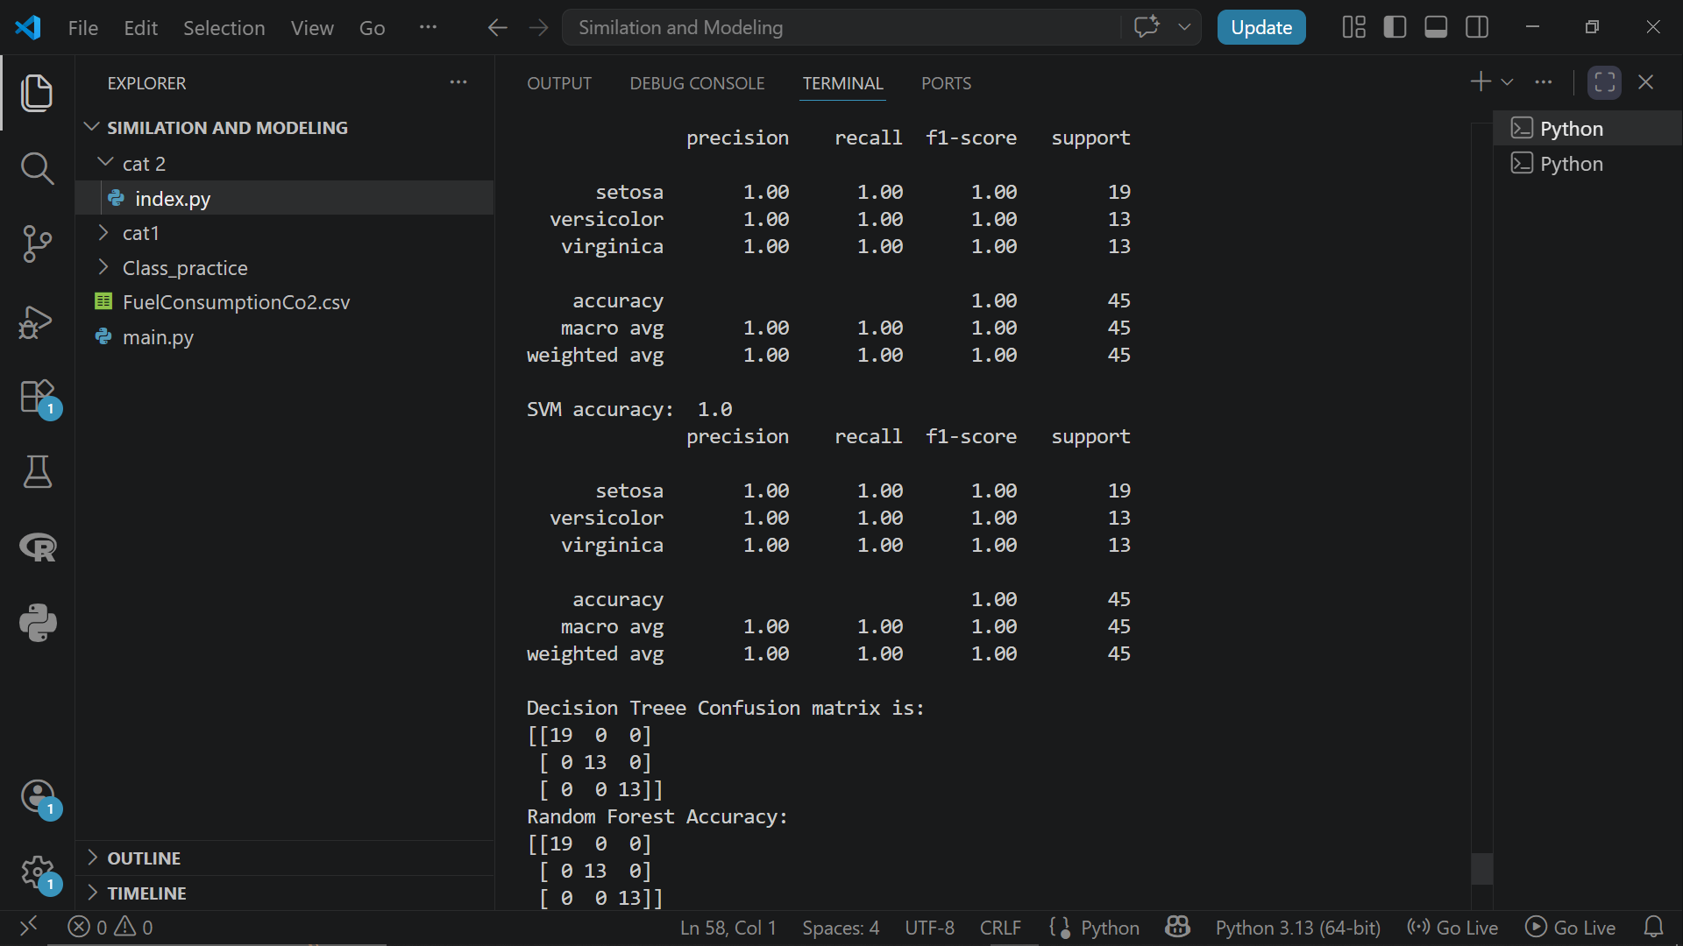
Question 3: Produce confusion matrix
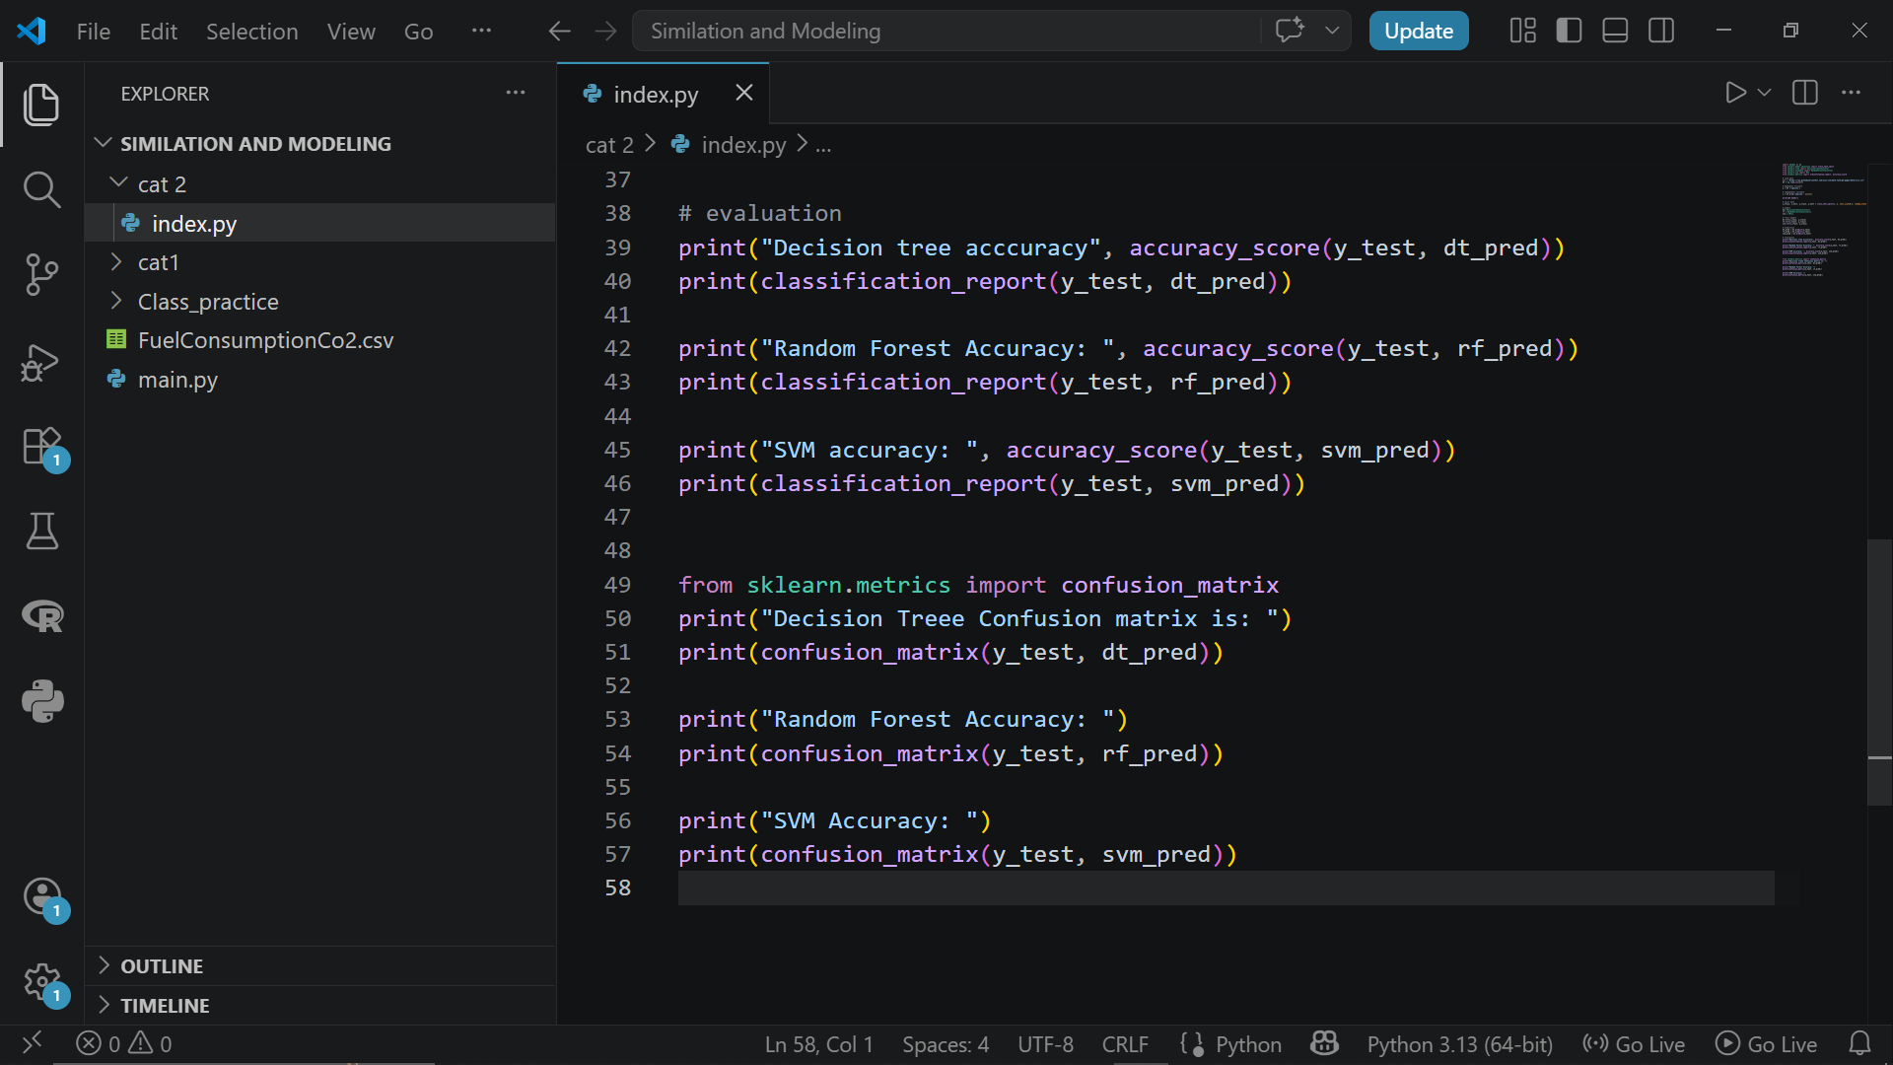
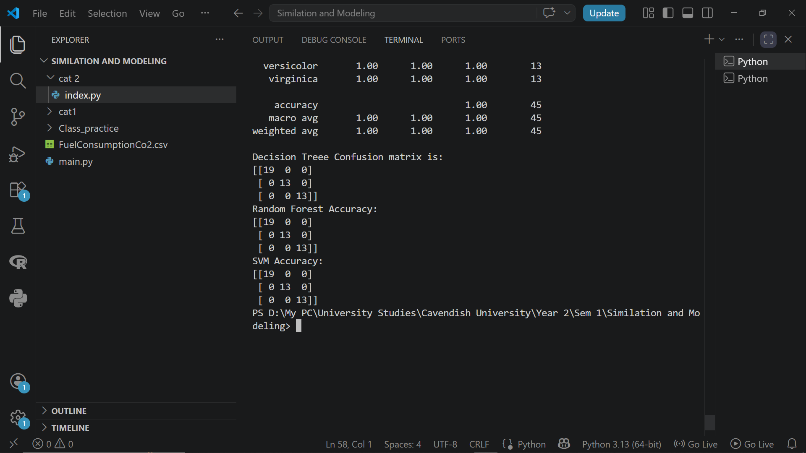

Question 4: Conclusion
After writing the code I noticed that everything was good since the code run without error and the output was clear. I noticed that:
- All three models performed well in classifying the Iris species
- Random forest and svm generally achieve higher accuracy compared to decision tree because they reduce over fitting.
- Random forest is performing well because of the combination of multtiplee trees

